CS 340 Project Two README
Grazioso Salvare Rescue Dashboard
Ashley Almanza

Project Overview
The purpose of this project was to create an interactive dashboard for Grazioso Salvare, an organization that identifies dogs that may be good candidates for search-and-rescue training. The application uses animal shelter data stored in MongoDB and allows the user to filter the available animals based on different rescue categories.
The dashboard was developed using Python and Dash and connects to MongoDB through the CRUD Python module created earlier in the course. The finished dashboard provides an interactive data table, rescue-type filtering options, a breed distribution chart, and geolocation map.

Required Functionality
The dashboard allows the user to view and interact with animal shelter records stored in the MongoDB database. When the dashboard initially loads or the Reset option is selected, the application displays the unfiltered animal records.
Four filtering options are available:
- Water Rescue
- Mountain or Wilderness Rescue
- Disaster or Individual Tracking
- Reset
Selecting one of the rescue options sends the appropriate query to MongoDB. The results are then displayed in the interactive data table. The table supports pagination, sorting, filtering and row selection to make the data easier to navigate.
The dashboard also contains two visualizations. A pie chart displays the distributions of breeds within the currently filtered data. A geolocation map uses the latitiude and longitude information from the selected animal record to display its location. These components update as the data displayed by the dashboard changes.

Dashboard Testing
Starting State/Reset
The Reset option returns the dashboard to its original unfiltered state. The data table displays the complete dataset rather than animals belonging to a particular rescue category. The breed chart also updates to represent the breeds in the unfiltered dataset, while the map displays the location associated with the selected record. 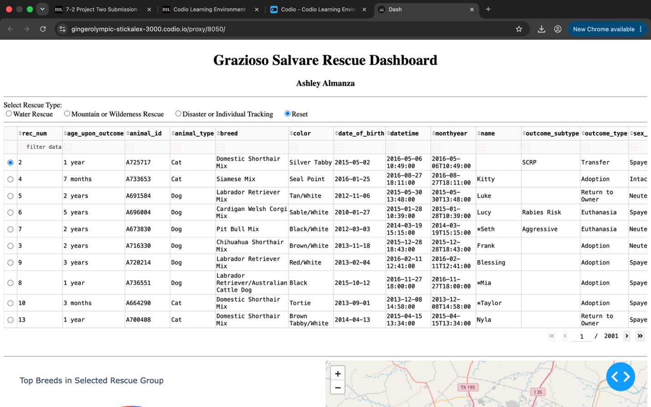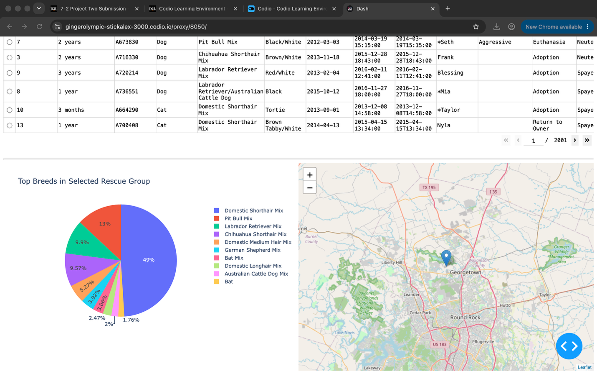

Water Rescue
Selecting Water Rescue filters the database for dogs that meet the requirements for water rescue training. During testing, the dashboard successfully updated the data table while matching records. The breed visualization and geolocation map also updated based on the filtered information. 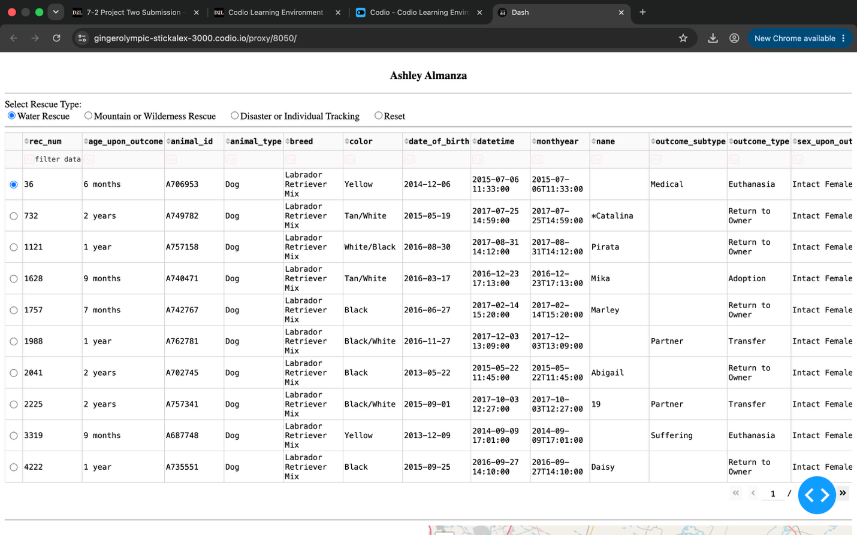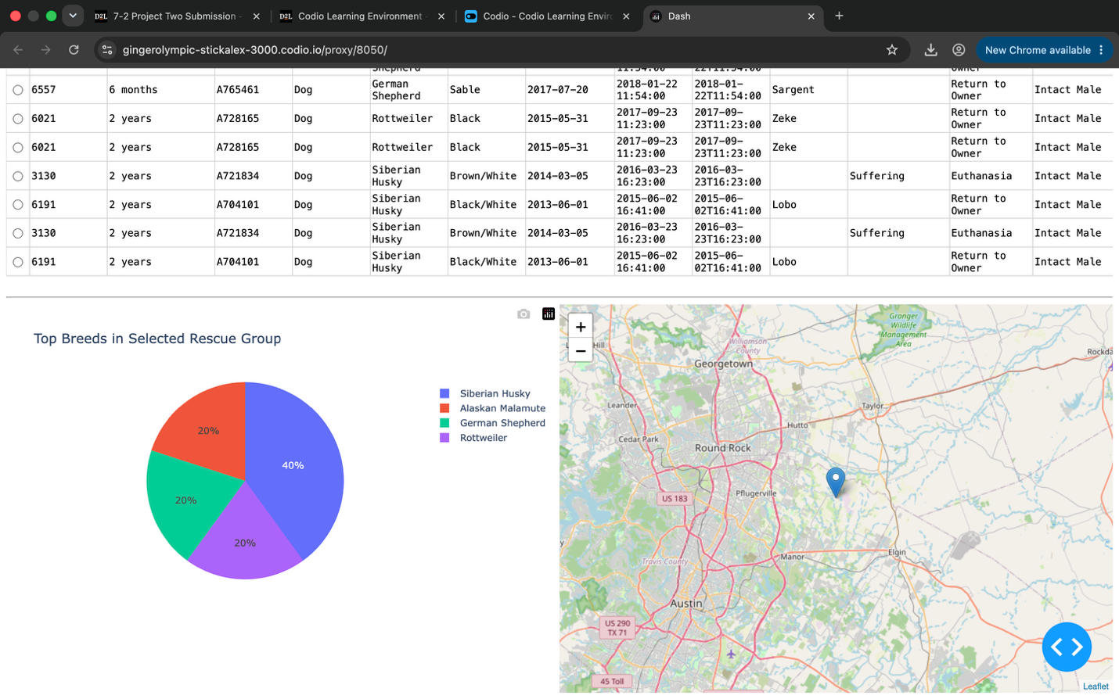

Mountain or Wilderness Rescue
Selecting Mountain or Wilderness Rescue updates the database query to locate dogs that match the requirements for this rescue category. Testing returned qualifying breeds including Alaskan Malamute, German Shephard, Rottweiler, and Siberian Husky. The breed chart changed to represent the filtered results, and the map displayed the location of the selected animal.

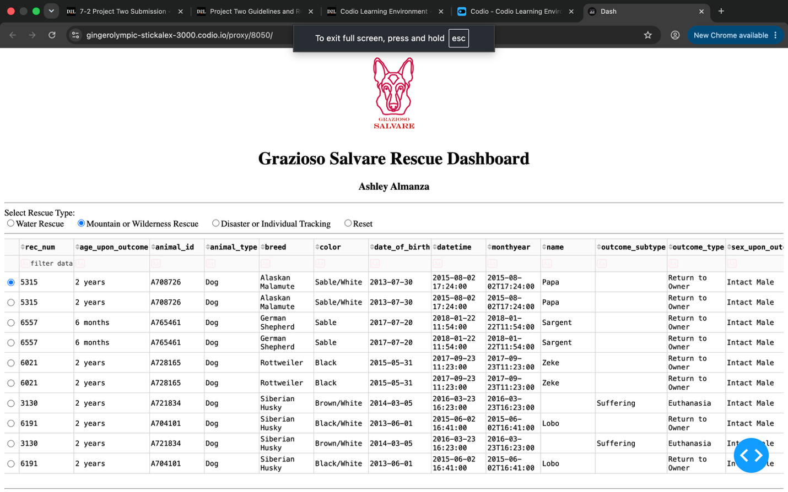
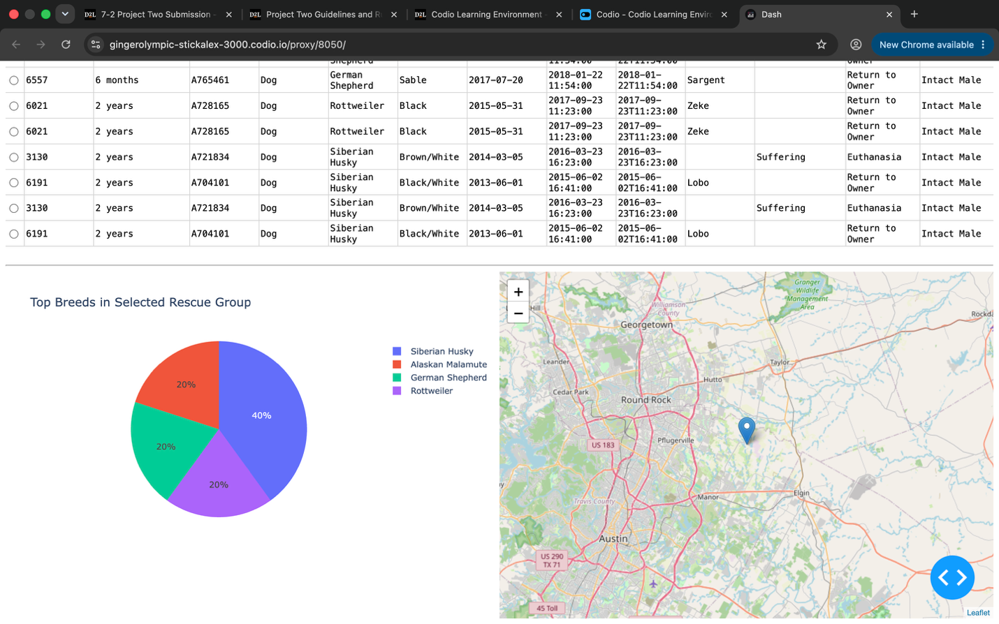

Disaster or Individual Tracking
The Disaster or Individual Tracking option filters the data for dogs that meet the criteria for this type of search-and-rescue work. Testing returned qualifying animals including Bloodhounds, German Shepherds, and Rottweilers. The data table, breed chart, and map responded to the filter as expected. 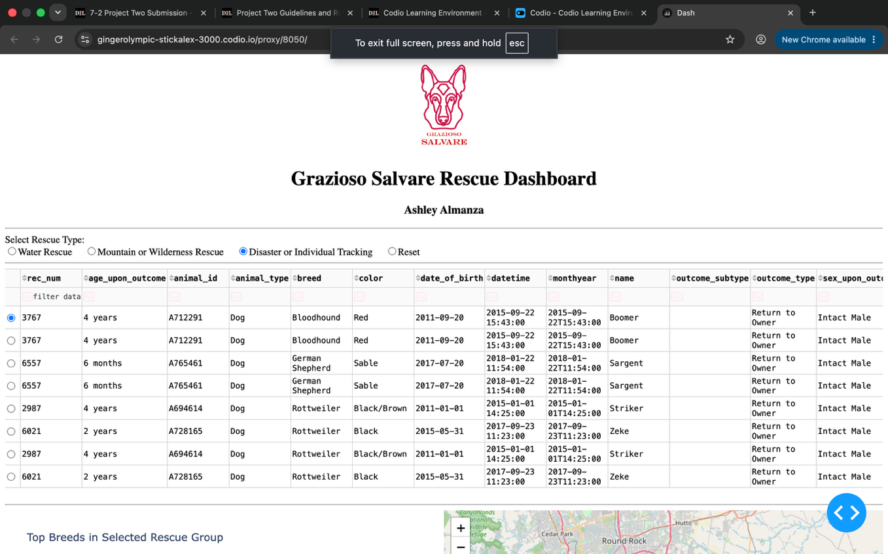

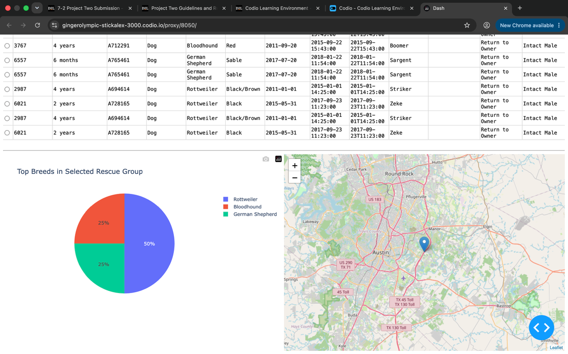

Tools and Technologies
Several technologies were used to develop the dashboard.
MongoDB
MongoDB was used as the model component of the application. MongoDB is a NoSQL document database that stores information in flexible, JSON-like documents. This works well with the animal shelter dataset because each animal can be represented as a document containing information such as breed, age, sex, outcome, and location.
MongoDB also works well with Python through the PyMongo library. The CRUD module developed earlier in the course uses PyMongo to connect Python to the MongoDB database. This allows the dashboard to retrieve records by passing query documents to the read() method. The dashboard can therefore change its MongoDB query depending on which rescue option the user selects.
Python
Python was used for the application logic and for communication between database and dashboard. The existing AnimalShelter CRUD class provides Create, Read, Update, and Delete functionality for the MongoDB database. For this dashboard, the Read operation is primarily used to retrieve the records needed for each filter.
Pandas was also used to convert the MongoDB results into DataFrames. This made it easier to prepare the records for the Dash data table and visualizations.
Dash and JupyterDash
Dash provides the view and controller proportions of the application. Dash components were used to create the radio buttons, interactive data table, and visualization containers.
Dash callbacks act as the controller by responding to user actions. For example, when the user selects Water Rescue, the callback receives the selected value, creates the appropriate MongoDB query, retrieves the matching records, and updates the data table. Other callbacks then update the breed chart and map based on the displayed records.
JupyterDash was used so he Dash application could run from the Jupyter Notebook environment provided through Codio.
Plotly Express
Plotly Express was used to create the breed distribution pie chart. The chart provides a visual representation of the breeds contained within the current set of records and changes dynamically when the displayed data changes.
Dash Leaflet
Dash Leaflet was used to create the geolocation portion of the dashboard. The latitude and longitude fields contained in the animal shelter dataset are used to position a marker on the map. Selecting an animal from the data table allows its location to be represented geographically.
Development Process
I began the project by importing the required Python libraries and connecting the dashboard to MongoDB using the AnimalShelter CRUD module developed previously. I used the read() method with an empty query to retrieve the complete dataset and converted the results into a Pandas DataFrame.
The MongoDB _id field was removed from the DataFrame because the MongoDB ObjectId data type is not directly compatible with the Dash data table.
Next, I created the dashboard layout. I added the Grazioso Salvare logo, dashboard title, my identifying information, rescue-type radio buttons, an interactive data table, a pie chart and a geolocation map.
After creating the layout, I implanted callbacks to control interactive behavior of the dashboard. The primary callback determines which MongoDB query should execute based on the rescue category selected by the user. The query results are converted into a DataFrame and returned to the data table.
Additional callbacks were used to create the breed chart and map. The pie chart calculates the number of animals belonging to each breed within the displayed records. The map retrieves the latitude and longitude values for the selected animal and places and marker at that location.
Finally, I tested each rescue filter individually and verified that the data table and visualizations changed appropriately. I also tested the Reset option to verify that the dashboard returned to the complete, unfiltered dataset.
Challenges Encountered
One challenge during development involved completing the callback functions in the starter dashboard code. An unfinished callback caused an indentation error because Python requires an indented block after a function definition. I resolved this by completing the callback functions and then testing the notebook again.
Another issue involved the Grazioso Salvare logo. The starter code contained a placeholder image filename that did not match the actual image file available in Codio. This caused a FileNotFoundError. I corrected the filename so the application could locate and encode the provided Grazioso Salvare logo.
I also encountered a callback error involving the selected columns in the data table. When no column was selected, the callback could receive an empty value. I handled this condition before attempting to iterate through the selected columns.
Testing each component individually helped identify these problems before testing the complete dashboard. Once these issues were corrected, the filters, data table, breed chart, and geolocation map worked together as intended.
Reproducing the Project
To reproduce the project, the user must have access to Python, MongoDB, the required Python packages, the Austin Animal Center dataset, the Grazioso Salvare logo, the CRUD python module, and the dashboard notebook.
The MongoDB database should first be configured and populated with the animal shelter dataset. The database user msut have the appropriate permissions to read the animal records.
The required Python packages include JupyterDash, Dash, Dash, Leaflet, Plotly, Pandas, PyMongo, and the supporting Dash components.
The animal_shelter.py CRUD module and ProjectTwoDashboard.ipynb notebook should be located where the notebook an import the CRUD module. The Grazioso Salvare logo must also be available at the location referenced by the dashboard code.
After the MongoDB database is running and the required packages are installed, the notebook can be executed from beginning to end. The application will connect to MongoDB, retrieve the animal records, and launch the interactive dashboard.

Resources
Austin Animal Center. (2020). Austin Animal Center Outcomes [Data set]. City of Austin, Texas Open Data Portal. DOI: 10.26000/025.000001.

